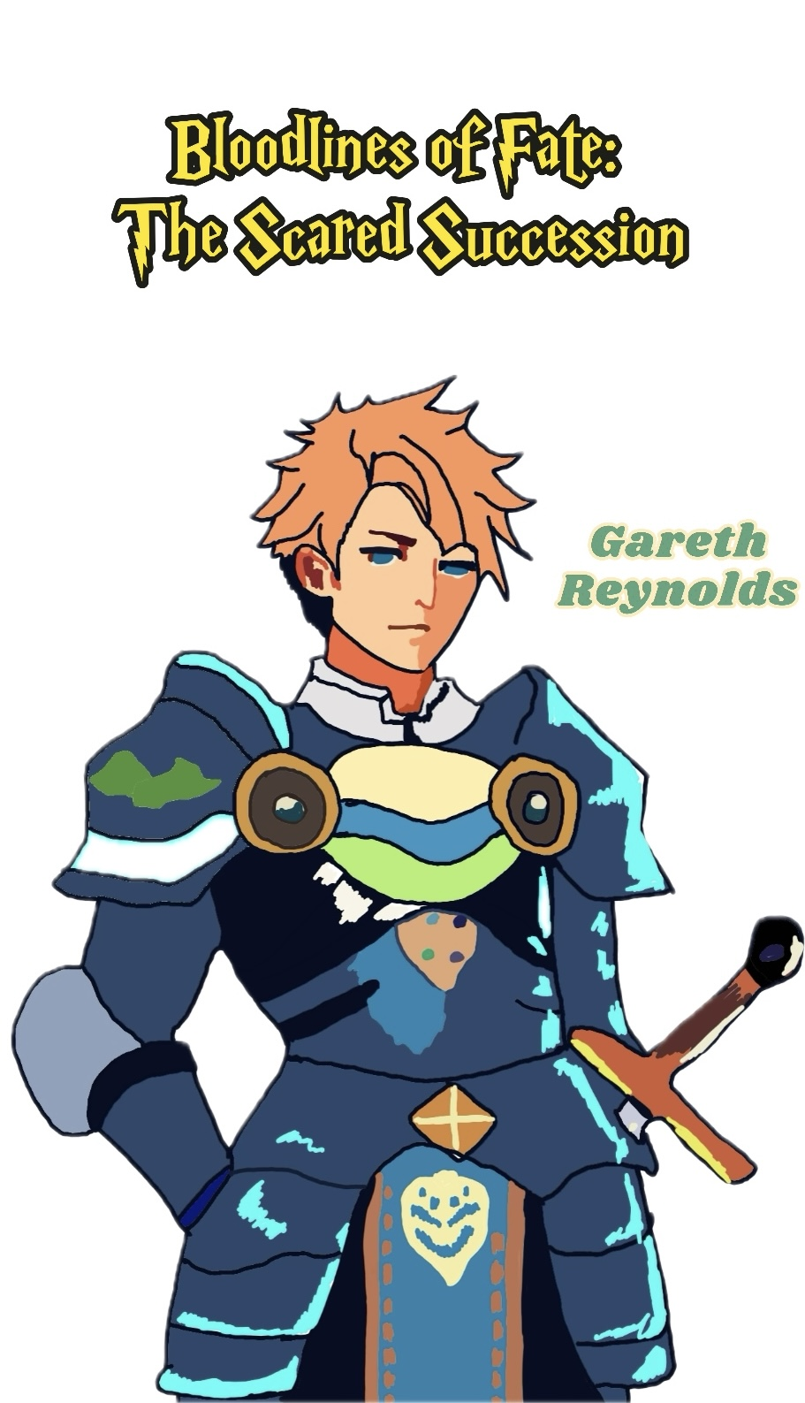

Gareth Reynolds Player Handbook
1. The setting of the story and the present
There are three countries on a continent: the Nagari Tribe, the Falor Theocracy, and the Caldean Kingdom. They are all fighting for power, identity, and survival. In the Caldean Kingdom, there is an absolute monarchy, and people think that noble blood has divine qualities. There are ten days left until the "Sacred Lion Succession Ceremony," where Prince Alfred will become king.
The Falor Theocracy was made by people who left Caldean many years ago in search of fairness. This ideal has not been fully realized, though, and the way power works in Falor has caused a gap between the leaders and the people.
People from the Nagari Tribe, who are led by former Caldean slaves, are fighting to stay alive. They fight back against the Caldean forces and want to make a place where their people can live easily and without being harmed.
2. Information about the player character
Who You Are:
Gareth Reynolds, a top member of Caldean's royal guard who always looked out for Prince Alfred. You were raised inside the palace walls with one goal in mind: to serve and protect the royal family. You will always be loyal to Alfred and the Caldean dynasty. You see the royal family as the embodiment of stability, order, and guidance chosen by God. You have spent your whole life protecting the prince because you think that when he becomes king, the country will continue to be prosperous.
Background and past events:
Your family has worked for the royal guard for many years and you were born into it. Your father was a skilled warrior who fought for the country all his life, and you always looked up to him. He told you stories as a child about being brave, loyal, and courageous, and you knew from a very young age that you wanted to be like him. Your family lived in Yalma, the main city, which was close to the palace. As a child, you trained with wooden swords and dreamed of one day being able to serve the crown.
At age ten, you were picked to be Prince Alfred's friend. This was a great honor for your family. After that, the house became the center of your life. You trained with Alfred and learned how the court worked. You were also taught that the "Blood of the King" was holy and that protecting the royal family was the most important thing anyone could do. Alfred was more than just your prince. You trusted and looked up to him as a friend. You were there for his lessons, training, and even times when he wasn't sure what to do. Your relationship with him went beyond that of guard and prince.
Your training was very hard. You learned how to fight accurately, ride a horse, and use a sword. You learned to be disciplined and do your job from the royal guard teachers. You learned to put the kingdom ahead of everything else, even your own life. As time went on, you proved to be one of the best young guards in Caldean, known for being strong, loyal, and good at strategy. People in high places trusted you, and the other guards looked up to you. You were happy to serve, and you never wonder why you were doing what you were doing.
That being said, your loyalty was put to the test ten years ago at the last "Sacred Lion Succession Ceremony." Prince Leo, Alfred's uncle, betrayed the royal family during the event. It was a shocking event that made the whole land shake. You were told to help look for Leo, but he got away, leaving behind questions that the royal family never answered. The event made you feel like you failed, and you still do that today. You made a promise that you would never let something like that happen again after the betrayal.
You still strongly believe that the royal family was chosen by God to be in charge. You believe in the holy power of the "Blood of the King" and have faith that Prince Alfred will be a fair and smart leader. You think that the chaos and unrest outside the kingdom are caused by people who don't understand that the royal family stands for order and God's will. You think Falor's ideas about equality are dangerous and meant to make the country less stable. You also think the Nagari Tribe betrayed their masters and are criminals.
Even though you are very faithful, you know that most people are having a hard time. During your patrols through the city, you've seen how poor people are and heard them complaining. You feel sorry for the people, and it hurts you to know that many are in pain. But you think that these problems can be fixed with strong leadership, like Prince Alfred's rule. You believe that once he takes the throne, everything will be better for everyone, and you are eager to help him reach his goal.
3. How to Hide Things
You are beginning to have questions about what the "Blood of the King" really is. Even though you've never said it out loud, what happened at the last succession ceremony and the rumors you hear from regular people have made you start to doubt it. You keep these thoughts to yourself because you know they could be seen as traitorous. You also feel bad that you weren't able to stop Prince Leo from betraying the kingdom; you still blame yourself for that mistake.
4. Thoughts on Other Player Characters
Alfred Caldean: I am your prince, your friend, and the heir to the throne who was born to rule. You have a close relationship with Alfred because you know him from childhood. You are determined to keep him safe because you think he has what it takes to be a great king. You believe that his ascension will bring stability back to Caldean and that he will make decisions that are good for the country.
Elias Caldean is the son of Prince Leo, who betrayed the country and ran away. It's hard for you to decide how to feel about Elias because he is both royal and the son of a rebel. You don't know what he really wants, and having him in Falor makes you feel nervous. He might be a threat to Prince Alfred's rule if he is like his father. You keep a close eye on him and are ready to act if needed.
Selena Noth is a spy for Falor and is part of his network. You think of Selena as a dangerous enemy who wants to bring down the country. You think that her devotion to Falor's theory of equality is misguided and that it puts Caldean at risk. You are wary of her and don't trust her because you think she might be gathering information about the royal family to use against them.
Khal Amir is the leader of the Nagari Tribe, and Arya Amir is his daughter. You see her as a personification of defiance—someone who stands for the chaos that happens when you go against the natural order. You know how kind she is and how much she wants to help her people, but you can't forget about her family history and how dangerous the Nagari Tribe is to Caldean. Some of you still wonder if there might be another way to make peace between your people and hers.
5. Goals for Character
The public goal is to keep Prince Alfred safe and make sure he can become king. It is important to you that the country stays stable and that the royal family's power is protected.
Secret Goal:
To face your concerns about "Blood of the King." You want to know the truth about the succession and why Prince Leo left the royal family. You will always be loyal to Prince Alfred, but you are motivated to find out the secrets that have been kept from you. You also feel the weight of your past mistake, and you're set on making sure that nothing threatens Prince Alfred's future, no matter what it takes.

